Document on secret-yaml-files:

- Login to the server and start with sudo su command to become a root user.

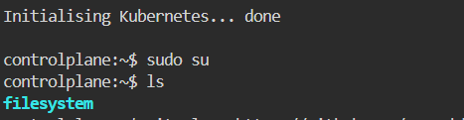

- Then clone the given git repository
- After cloning check the cloned repo by ls command.

Command: git clone <URL of git>

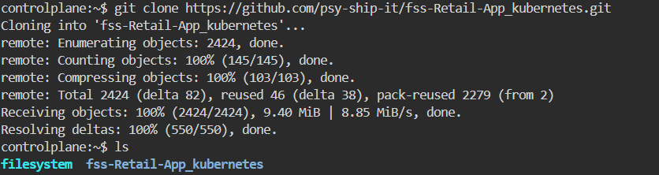

- Then go into the directory
Command: cd <directory name>

- Then check for the k8-manifest directory
Command: ls

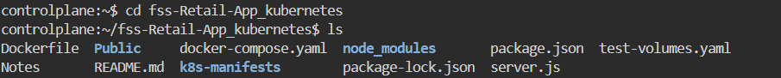

- Then go into the k8-manifest directory
Cmd: cd <directory name>

- Then create a file vi configmap.yaml

apiVersion: v1
kind: ConfigMap
metadata:
name: retail-app-config
namespace: secret-ns
data:
MONGODB_URI: "mongodb://mongodb:27017/myDatabase"
SESSION_SECRET: "1234"
PORT: "3130"
MONGO_INITDB_DATABASE: "myDatabase"

- Then create a name space
Cmd: kubectl create ns <name>

- Then apply the file and check for the running data

Cmd: kubectl apply -f configmap.yaml (this cmd is used to apply the yaml file)
Kubectl get cm -n secret-ns(this cmd is used check all the data applied or not)

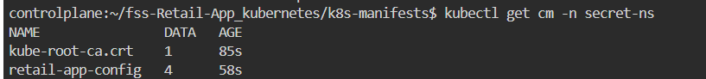

- Change the file name and remove the data present in the file and add the new file data
Cmd: mv userprofile-deployment.yml retail-app-deployment.yaml(this cmd is used to change the name of the file)

> retail-app-deployment.yaml(this cmd is used remove the data present inside the file)
vi retail-app-deployment.yaml (this cmd is used to add the yaml file into the file)

Yaml file:
apiVersion: apps/v1
kind: Deployment
metadata:
name: retail-mongodb
namespace: secret-ns
spec:
replicas: 1
selector:
matchLabels:
app: mongodb
template:
metadata:
labels:
app: mongodb
spec:
containers:
- name: mongodb
image: mongo:latest
ports:
- containerPort: 27017
env:
- name: MONGO_INITDB_DATABASE
valueFrom:
configMapKeyRef:
name: retail-app-config
key: MONGO_INITDB_DATABASE

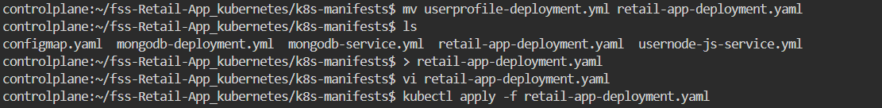

- Change the file name and change the namespace

Cmd: mv usernode-js-service.yml retail-app-svc.yaml(this cmd is used to change the name of the file)

- Change the file name and remove the data present in the file and add the new file data
Cmd : mv mongodb-deployment.yml retail-mongodb-deployment.yaml (this cmd is used to change the name of the file)

> retail-mongodb-deployment.yaml(this cmd is used remove the data present inside the file)
vi retail-mongodb-deployment.yaml(this cmd is used to add the yaml file into the file)

Yaml file:
apiVersion: apps/v1
kind: Deployment
metadata:
name: retail-mongodb
namespace: secret-ns
spec:
replicas: 1
selector:
matchLabels:
app: mongodb
template:
metadata:
labels:
app: mongodb
spec:
containers:
- name: mongodb
image: mongo:latest
ports:
- containerPort: 27017
env:
- name: MONGO_INITDB_DATABASE
valueFrom:
configMapKeyRef:
name: retail-app-config
key: MONGO_INITDB_DATABASE

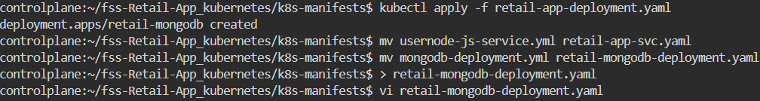

- Change the file name and remove the data present in the file and add the new file data
Cmd: mv mongodb-service.yml retail-mongodb-svc.yaml(this cmd is used to change the name of the file)

- Then apply the file and check for running data

Cmd: kubectl apply -f configmap.yaml(this cmd is used to apply the yaml file)
kubectl get all -n secret-ns(used to check all the running data)

- Then apply the file and check for running data

Cmd: kubectl apply -f retail-mongodb-deployment.yaml(this cmd is used to apply the yaml file)
kubectl get all -n secret-ns(this cmd is used to check all the status and data)

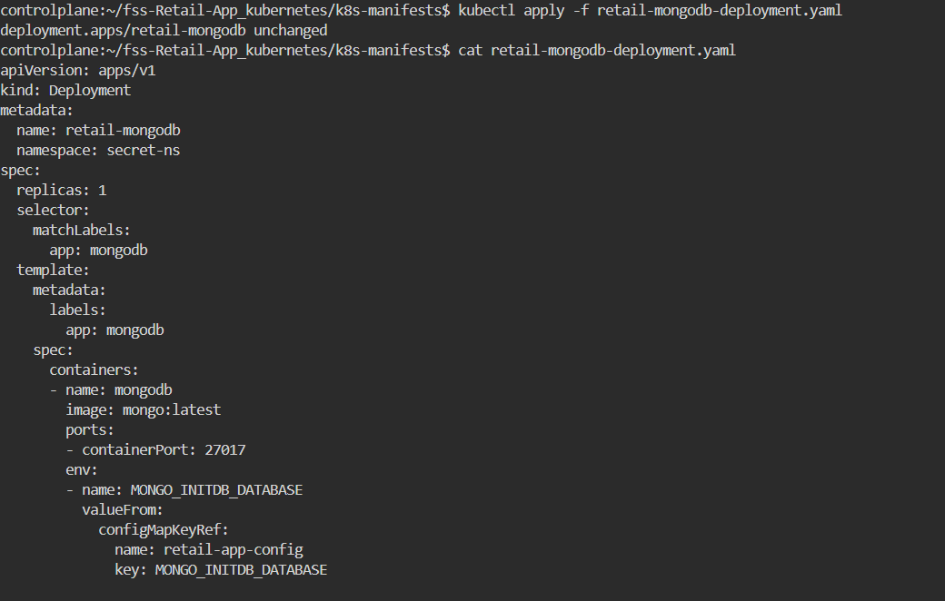

- Then apply the file and check for running data

Cmd: kubectl apply -f retail-mongodb-svc.yaml(this cmd is used to apply the yaml file)
kubectl get all -n secret-ns(used to get all the running status of the data)

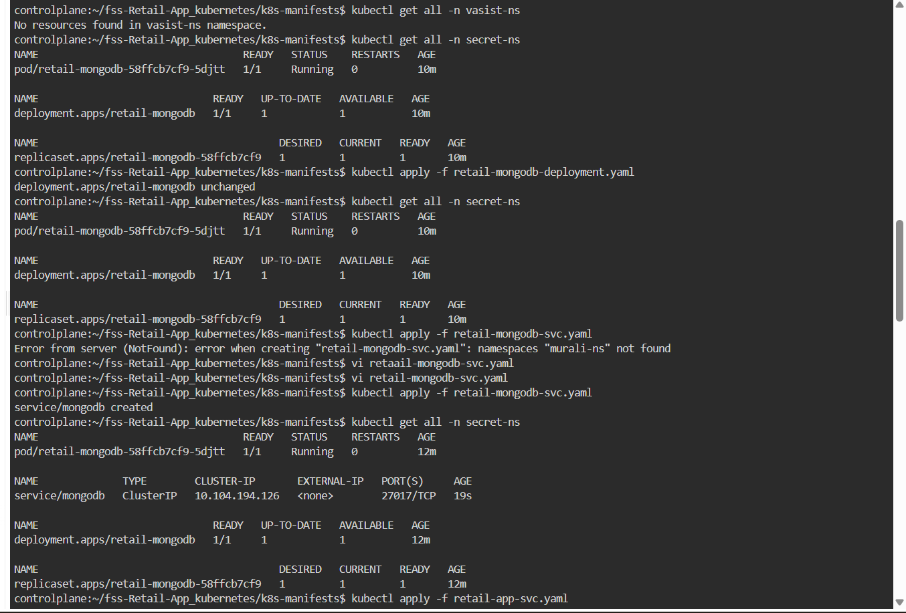
- Then apply the file and check for running data
Cmd: kubectl apply -f retail-mongodb-deployment.yaml(this cmd is used to apply the yaml file)

Cmd: kubectl apply -f retail-app-svc.yaml(this cmd is used to apply the yaml file)

kubectl get all -n secret-ns(used to get all status of data and all the working report)



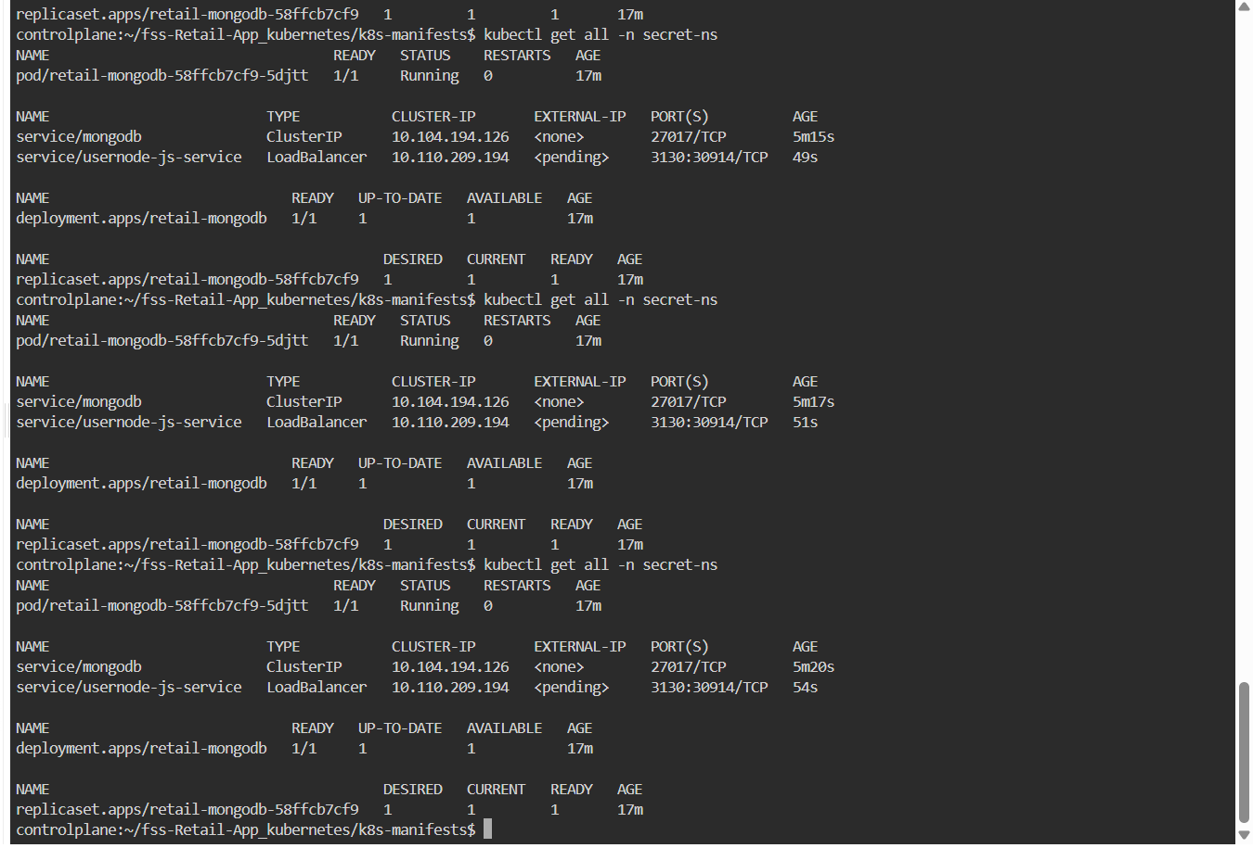

18. Check the status of the application:

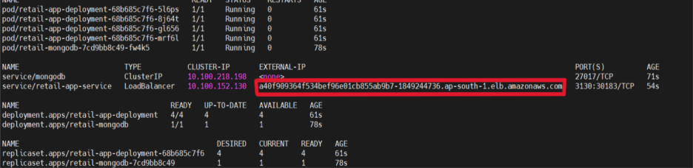

19. Open a Linux shell inside the MongoDB container and check files inside the container.
Cmd: kubectl exec -it retail-mongodb-7cd9bb8c49-fw4k5 -n secret-ns -- /bin/sh
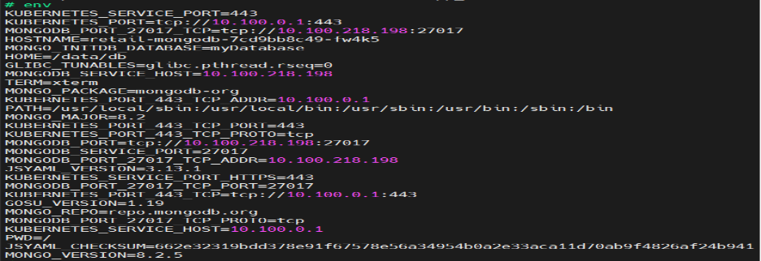

20. Open the MongoDB shell directly:
Cmd: kubectl exec -it retail-mongodb-7cd9bb8c49-fw4k5 -n secret-ns – mongosh
To view, use the databases and shows all documents in the products collection.

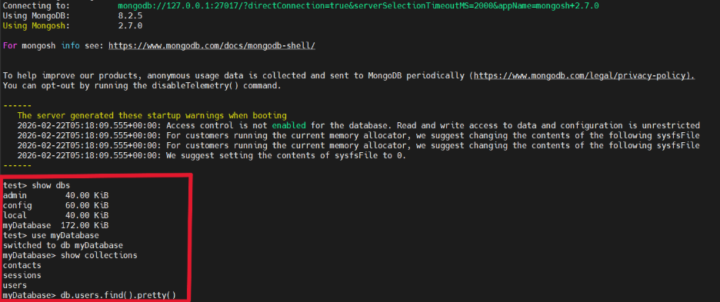

21. Copy the External IP and paste it in browser:
It will get us to the home page.
The final site output:

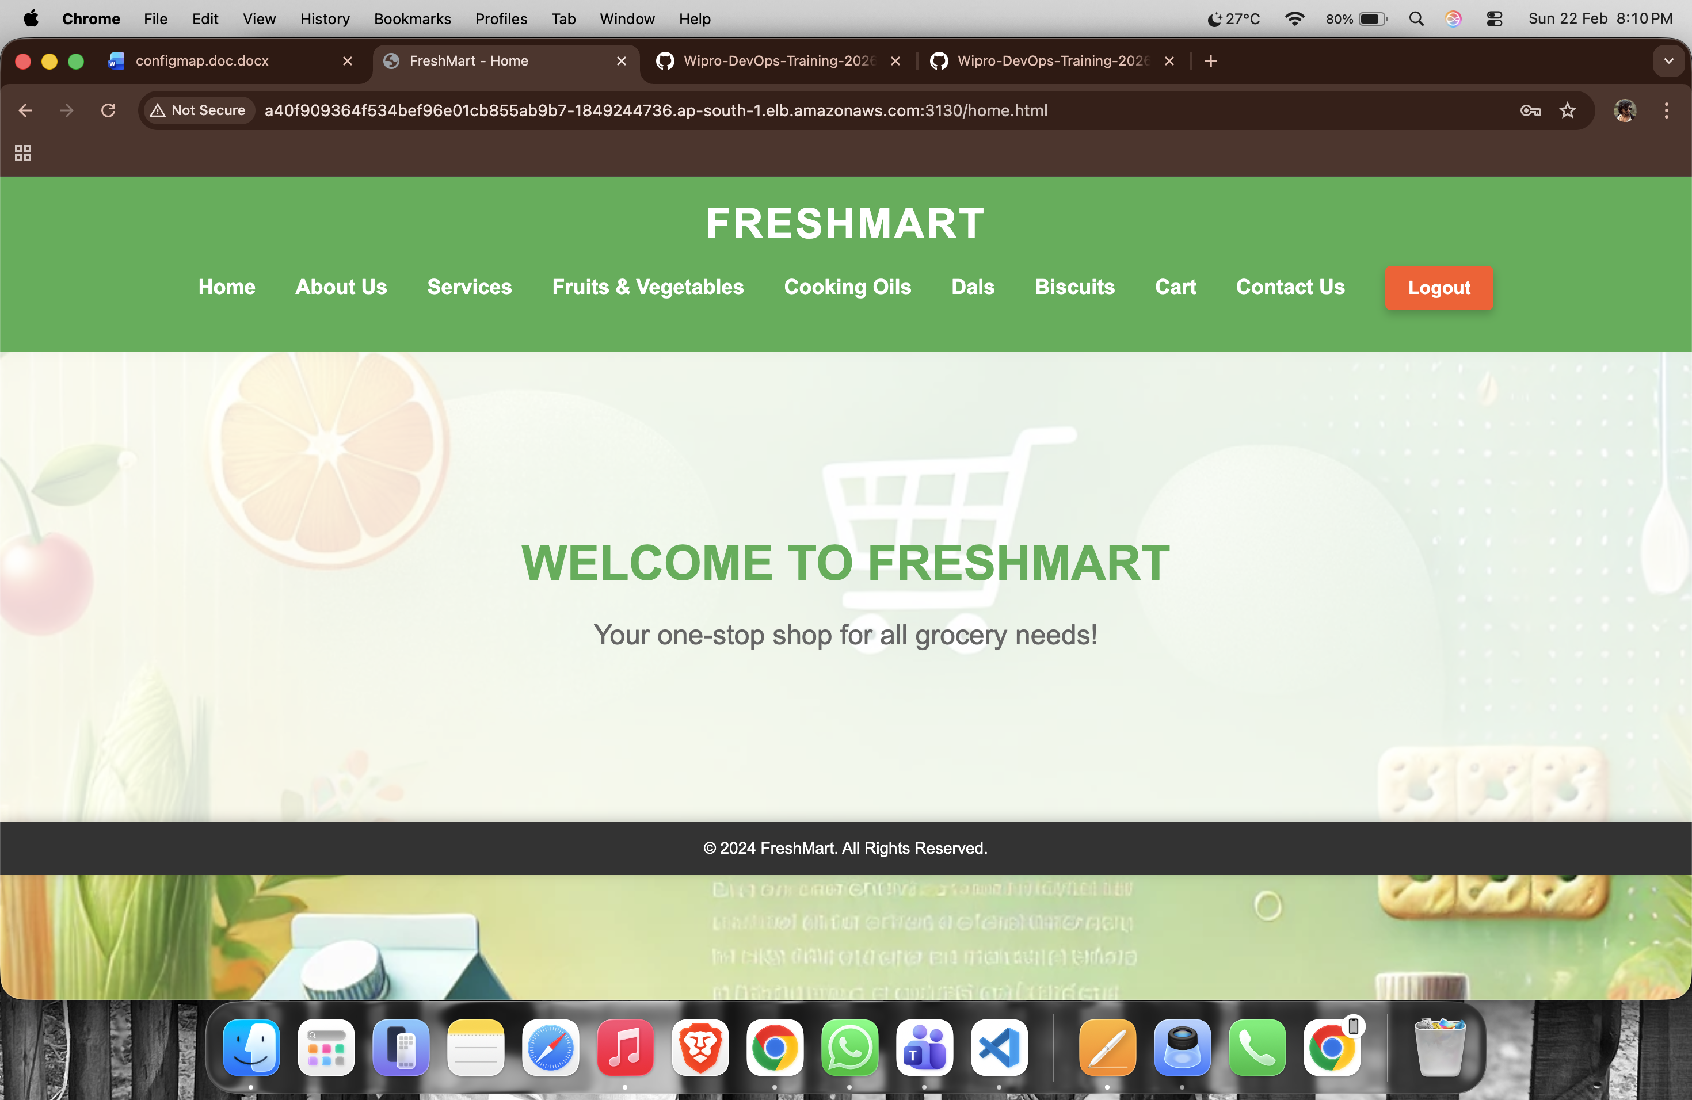

SECRET YAML FILE

> A Secret is a Kubernetes object used to store sensitive data such as passwords, tokens, API keys, or certificates. The data is stored in Base64-encoded format.
==> echo -n 'chagantyteja2502@gmail.com' | base64
- echo -n → prints the text without adding a newline
- | → sends output to the next command
- base64 → encodes the input into Base64 format

chagantyteja2502@gmail.com
↓
Y2hhZ2FudHl0ZWphMjUwMkBnbWFpbC5jb20=
==> echo -n 'yxoq bjuk rdnt alzp' | base64
yxoq bjuk rdnt alzp
↓
eXhvcSBianVrIHJkbnQgYWx6cA==
==> echo -n 'Y2hhZ2FudHl0ZWphMjUwMkBnbWFpbC5jb20=' | base64 –decode
==> decodes the input
Y2hhZ2FudHl0ZWphMjUwMkBnbWFpbC5jb20=
↓
chagantyteja2502@gmail.com

- Vi secret.yaml
Create secret yaml file
apiVersion: v1
kind: Secret
metadata:
name: retail-app-secret
namespace: secret-ns
type: Opaque
data:
EMAIL_USER: Y2hhZ2FudHl0ZWphMjUwMkBnbWFpbC5jb20=
EMAIL_PASS: eXhvcSBianVrIHJkbnQgYWx6cA==

2) kubectl apply -f secret.yaml
Apply the file:
3) kubectl get secret –n secret-ns
- Lists all Secrets in the current namespace
- Shows secret name, type, and age

